**Project Report of Fantastic’s foodies feed**

**Fantastic’s Foodies Feed**

**“Education through self-help is our motto” – KARMAVEER**



**RAYAT SHIKSHAN SANSTHA’S**

**KARMAVEER BHAURAO PATIL COLLEGE**

**VASHI, NAVI MUMBAI -400703**

**[AUTONOMUS COLLEGE]**

**DEPARTMENT OF COMPUTER SCIENCE**

**CERTIFICATE**

This is certify that  **Pranali Kirolkar** students of T.Y. BSC (CS) from Karmaveer Bhaurao Patil College, Vashi Navi Mumbai has satisfactorily completed Final Year sem 5 project course in Computer Science as per the syllabus laid by Maharashtra State Board of technical education during the academic year 2018-2019.

Roll no: - **187519**.

Teacher In-charge Head

Date: / /2018 Dept of Computer Science

**“Education through self-help is our motto” – KARMAVEER**



**RAYAT SHIKSHAN SANSTHA’S**

**KARMAVEER BHAURAO PATIL COLLEGE**

**[AUTONOMUS COLLEGE]**

**VASHI, NAVI MUMBAI -400703**

**DEPARTMENT OF COMPUTER SCIENCE**

**Fantastics Foodies Feed**

**Guided by :-**

**Prof. Nikisha Gawand.**

**Project submitted By:-**

1. **Pranali Piraji Kirolkar (187519)**

**INDEX**

|  |  |  |
| --- | --- | --- |
| **SR**  **NO.** | **Name of Content** | **Page**  **No.** |
| 01 | Title page | 01 |
| 02 | Certificate | 02 |
| 03 | Introduction | 05 |
| 03 | Requirements Specifications | 06 |
| 04 | System Design Details | 09 |
| 05 | System Implementation |  |
| 06 | Results |  |
| 07 | Conclusion |  |
| 08 | References |  |

**Introduction**

This project is based on the food reviews and famous places around you. To analyze specific areas famous food items and their restaurant, hotels or any specific area. To get the information about tastiest food around you. Eating healthy is the key for your mind and body to work properly.

Food is any substance consumed to provide nutritional support for an organism.

Some food sites splash mouth-watering pictures of delicious dishes across their pages and make us want to rush right out to eat. Others use the vibrant colors of food as a jumping-off point for a beautiful design. And still others integrate it into the functionality of the site, turning food into buttons, page loading devices, and more.

**Requirements Specifications**

* Front end-
  + - * + HTML,CSS,JAVA SCRIPT
* Back end-
  + - MySql
* OS-
  + window 10
* Software :- R Studio

1. **Table format of data set**

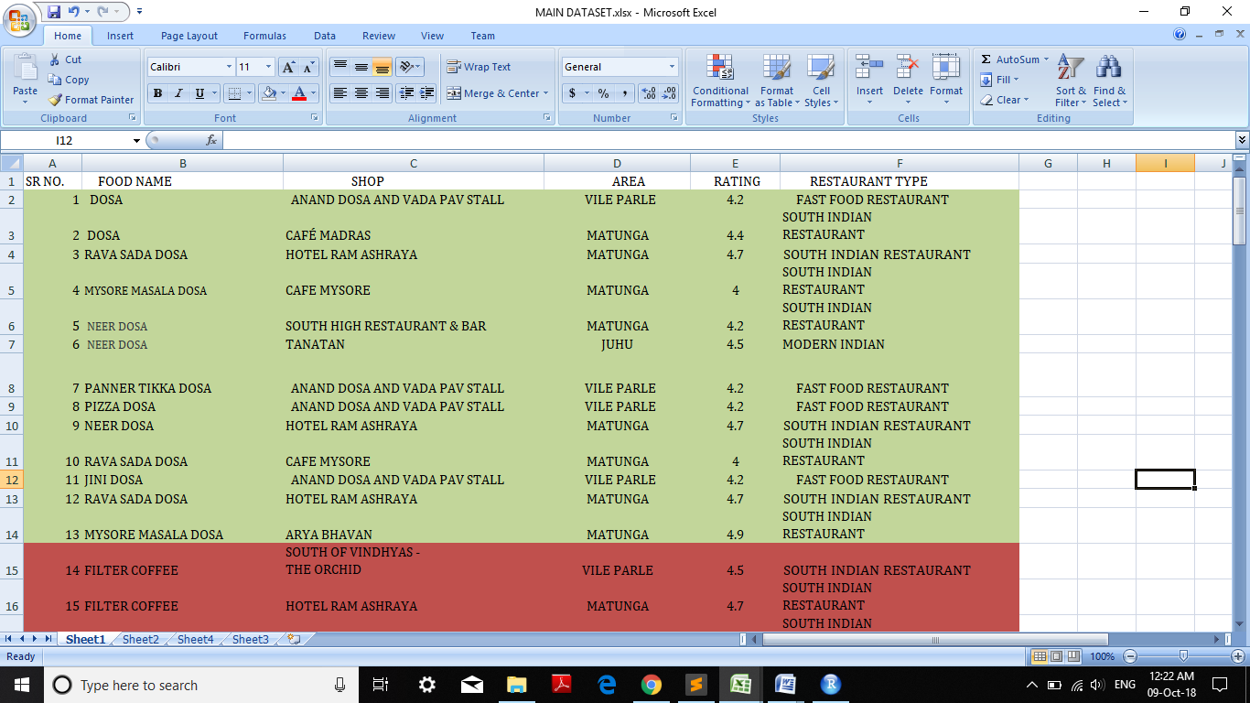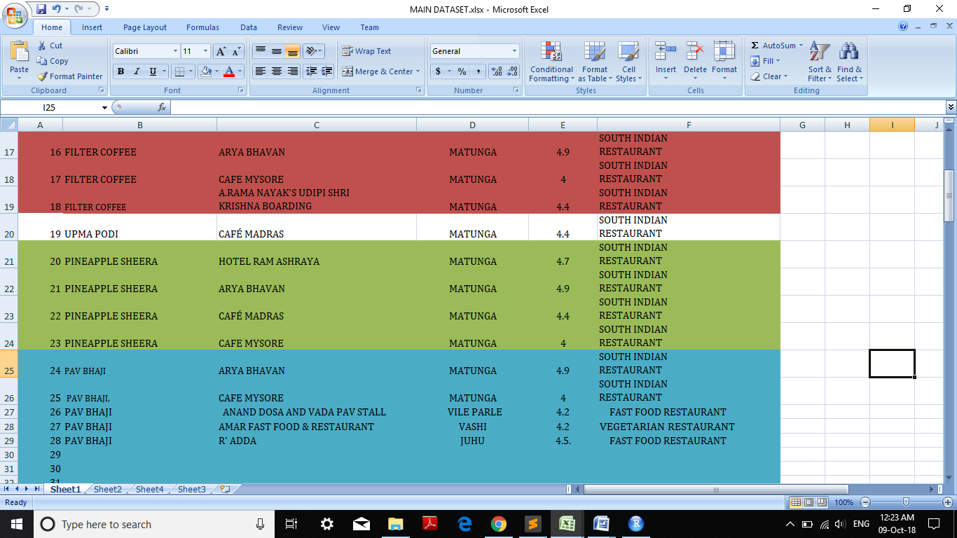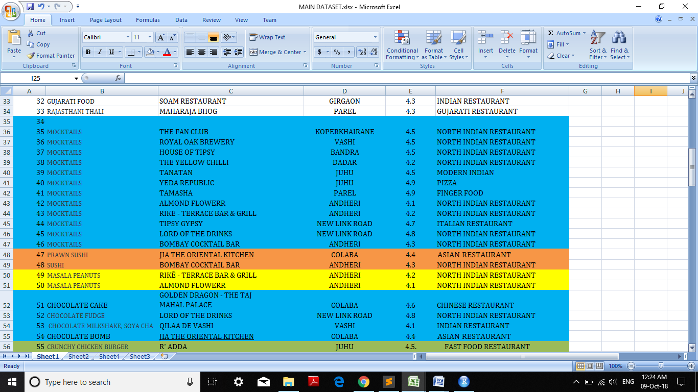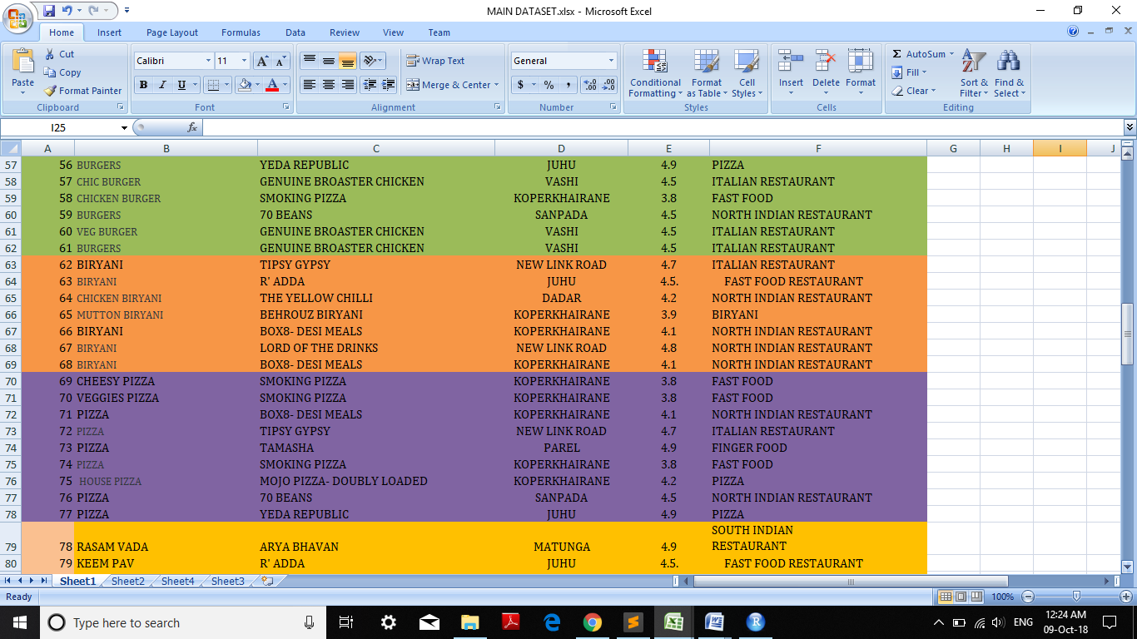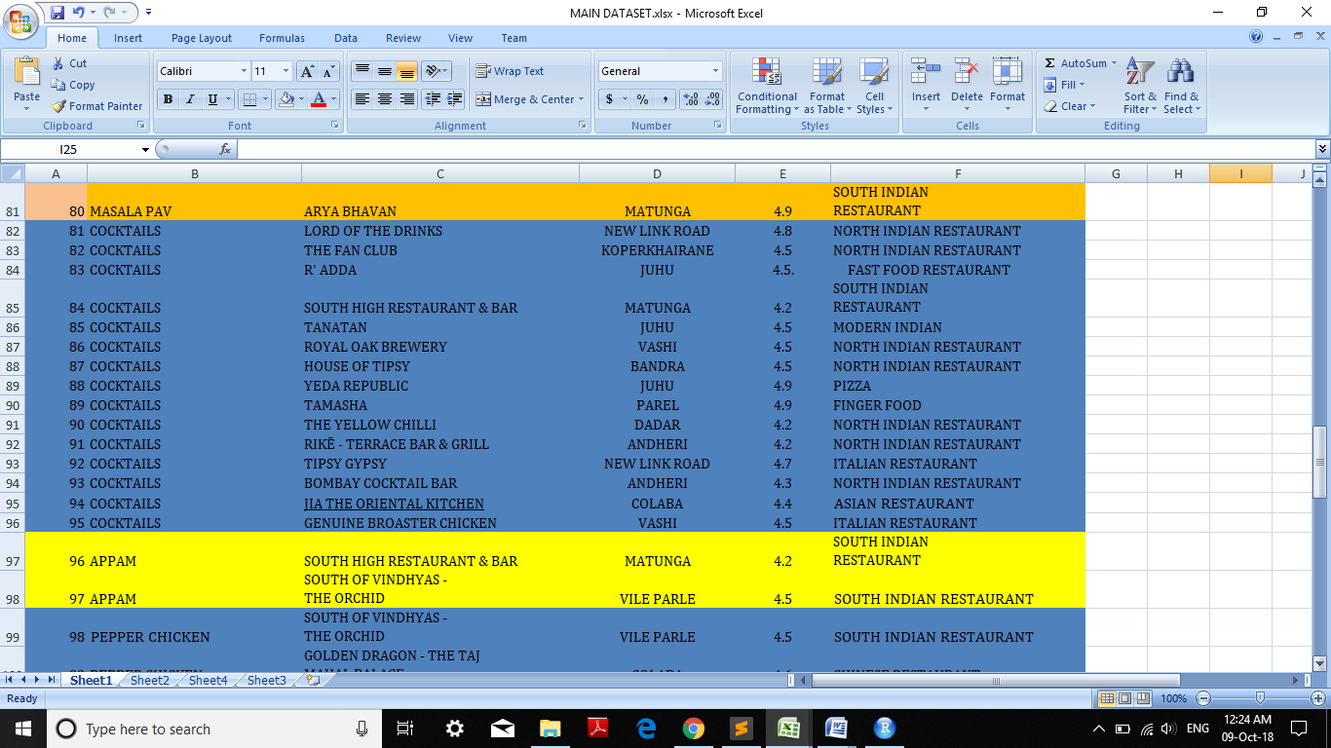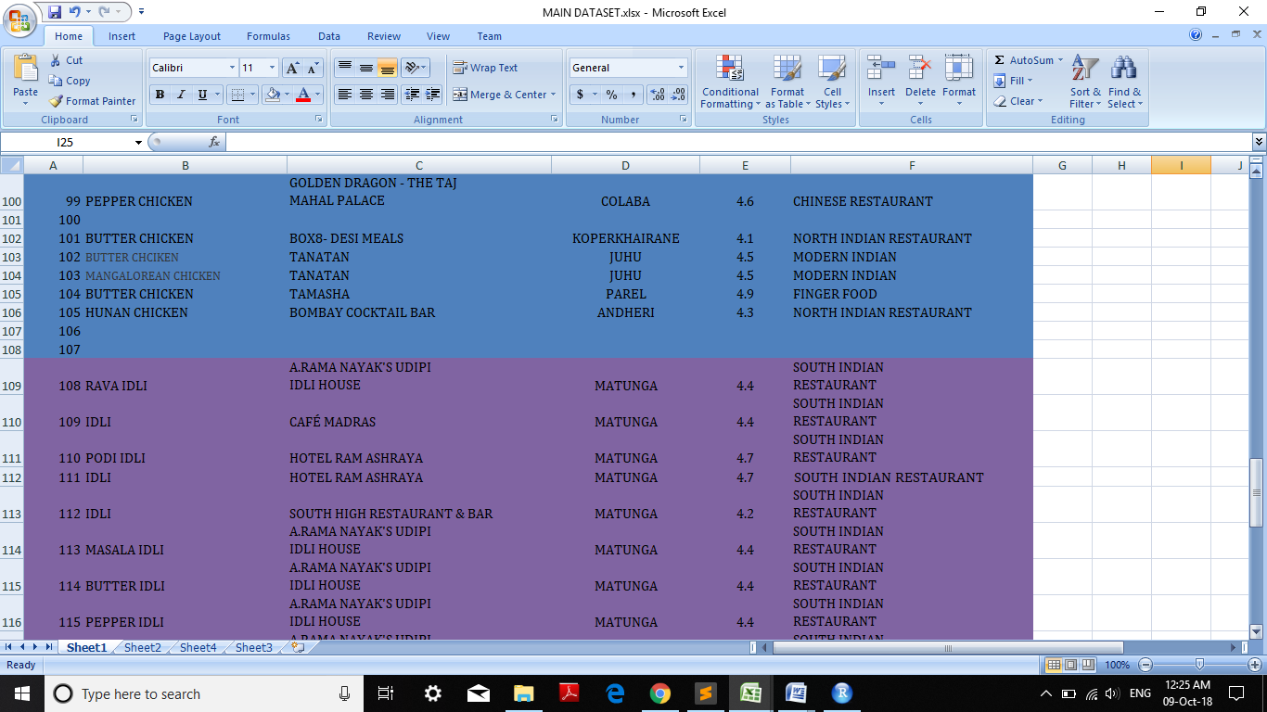

**System Design Details**

1. **Flowchart**

Home Page (Main Page)

**|**

To select one of the options of nav bar i.e. **FOOD ITEM OR FOOD PLACE**.

**|**

Then cursor goes to the corresponding link pages.

**|**

If you are select **FOOD PLACE** then number of food place will be shown then select one of the food place in dropdown menu.

**|**

Then cursor goes to the dropdown menu link pages.

**|**

Then main area of food place.

**|**

Graphical representation of main area.

**|**

Then famous food place in selected area.

**|**

Then graphical representation of famous food place in selected area.

**|**

**Map view** of famous food places.

1. **LIBRARY IN R STUDIO:-**

lattice library package

1. **Methodology-**

**System Implementation**

**home.html**

<!DOCTYPE html>

<html>

<head>

<meta charset="utf-8">

<meta name="viewport" content="width=device-width, initial-scale=1.0">

<title>Home</title>

<link rel="stylesheet" href="assets/bootstrap/css/bootstrap.min.css">

<link rel="stylesheet" href="https://fonts.googleapis.com/css?family=Cookie">

<link rel="stylesheet" href="assets/css/styles.css">

<link rel="stylesheet" href="assets/css/Pretty-Footer.css">

<link rel="stylesheet" href="assets/css/footer.css">

</head>

<style type="text/css">

p

{

color: white;

}

</style>

<body>

<nav class="navbar navbar-inverse navbar-fixed-top">

<div class="container-fluid">

<div class="navbar-header"><a class="navbar-brand navbar-link menu" href="file:///C:/Users/Pranali/Desktop/FinalPro/home.html"><i class="glyphicon glyphicon-cutlery"></i> Foodies </a>

<button class="navbar-toggle collapsed" data-toggle="collapse" data-target="#navcol-1"><span class="sr-only">Toggle navigation</span><span class="icon-bar"></span><span class="icon-bar"></span><span class="icon-bar"></span></button>

</div>

<div class="collapse navbar-collapse" id="navcol-1">

<ul class="nav navbar-nav navbar-right menu">

<li class="active" role="presentation"><a href="file:///C:/Users/Pranali/Desktop/FinalPro/home.html">HOME </a></li>

<li role="presentation"><a href="file:///C:/Users/Pranali/Desktop/FinalPro/AboutUs/about.html">ABOUT US</a></li>

<li class="dropdown"><a class="dropdown-toggle" data-toggle="dropdown" aria-expanded="false" href="#">FOOD NAME<span class="caret"></span></a>

<ul class="dropdown-menu submenu" role="menu">

<li role="presentation"><a href="file:///C:/Users/Pranali/Desktop/FinalPro/dosa.html">DOSA</a></li>

<li role="presentation"><a href="file:///C:/Users/Pranali/Desktop/FinalPro/upmapodi.html">UPMA PODI</a></li>

<li role="presentation"><a href="file:///C:/Users/Pranali/Desktop/FinalPro/chicken.html">CHICKEN</a></li>

<li role="presentation"><a href="file:///C:/Users/Pranali/Desktop/FinalPro/pavbhaji.html">PAV BHAJI</a></li>

<li role="presentation"><a href="file:///C:/Users/Pranali/Desktop/FinalPro/gujaratifood.html">GUJARATI FOOD</a></li>

<li role="presentation"><a href="file:///C:/Users/Pranali/Desktop/FinalPro/rajasthanithali.html">RAJASTHANI THALI</a></li>

<li role="presentation"><a href="file:///C:/Users/Pranali/Desktop/FinalPro/birayani.html">BIRAYANI</a></li>

<li role="presentation"><a href="file:///C:/Users/Pranali/Desktop/FinalPro/idli.html">IDLI</a></li>

<li role="presentation"><a href="file:///C:/Users/Pranali/Desktop/FinalPro/vadapav.html">VADA PAV</a></li>

</ul>

</li>

<li class="dropdown"><a class="dropdown-toggle" data-toggle="dropdown" aria-expanded="false" href="#">JUNK FOOD<span class="caret"></span></a>

<ul class="dropdown-menu" role="menu">

<li role="presentation"><a href="file:///C:/Users/Pranali/Desktop/FinalPro/pizza.html">PIZZA</a></li>

<li role="presentation"><a href="file:///C:/Users/Pranali/Desktop/FinalPro/mocktails.html">MOCKTAILS</a></li>

<li role="presentation"><a href="file:///C:/Users/Pranali/Desktop/FinalPro/sushi.html">SUSHI</a></li>

<li role="presentation"><a href="file:///C:/Users/Pranali/Desktop/FinalPro/burgers.html">BURGERS</a></li>

<li role="presentation"><a href="file:///C:/Users/Pranali/Desktop/FinalPro/cocktails.html">COCKTAILS</a></li>

<li role="presentation"><a href="file:///C:/Users/Pranali/Desktop/FinalPro/sandwich.html">SANDWICH</a></li>

<li role="presentation"><a href="file:///C:/Users/Pranali/Desktop/FinalPro/nachos.html">NACHOS</a></li>

<li role="presentation"><a href="file:///C:/Users/Pranali/Desktop/FinalPro/brownie.html">BROWNIE</a></li>

<li role="presentation"><a href="file:///C:/Users/Pranali/Desktop/FinalPro/salad.html">SALAD</a></li>

</ul>

</li>

<li class="dropdown"><a class="dropdown-toggle" data-toggle="dropdown" aria-expanded="false" href="#">FOOD PLACE<span class="caret"></span></a>

<ul class="dropdown-menu" role="menu">

<li role="presentation"><a href="file:///C:/Users/Pranali/Desktop/FinalPro/vileparle.html">VILE PARLE</a></li>

<li role="presentation"><a href="file:///C:/Users/Pranali/Desktop/FinalPro/matunga.html">MATUNGA</a></li>

<li role="presentation"><a href="file:///C:/Users/Pranali/Desktop/FinalPro/juhu.html">JUHU</a></li>

<li role="presentation"><a href="file:///C:/Users/Pranali/Desktop/FinalPro/vashi.html">VASHI</a></li>

<li role="presentation"><a href="file:///C:/Users/Pranali/Desktop/FinalPro/girgaon.html">GIRGAON</a></li>

<li role="presentation"><a href="file:///C:/Users/Pranali/Desktop/FinalPro/parel.html">PAREL</a></li>

<li role="presentation"><a href="file:///C:/Users/Pranali/Desktop/FinalPro/koperkhairane.html">KOPERKHAIRANE</a></li>

<li role="presentation"><a href="file:///C:/Users/Pranali/Desktop/FinalPro/bandra.html">BANDRA</a></li>

<li role="presentation"><a href="file:///C:/Users/Pranali/Desktop/FinalPro/andheri.html">ANDHERI</a></li>

<li role="presentation"><a href="file:///C:/Users/Pranali/Desktop/FinalPro/dadar.html">DADAR</a></li>

<li role="presentation"><a href="file:///C:/Users/Pranali/Desktop/FinalPro/colaba.html">COLABA</a></li>

<li role="presentation"><a href="file:///C:/Users/Pranali/Desktop/FinalPro/sanpada.html">SANPADE</a></li>

</ul>

</li>

<li role="presentation"><a href="file:///C:/Users/Pranali/Desktop/FinalPro/map/map.html">FOOD MAP</a></li>

</ul>

</div>

</div>

</nav>

<div id="promo">

<div class="jumbotron">

<h1 id="cs">Manage your favourite places!</h1>

<p>We show all the statistics of foods by ratings.</p>

<p><a class="btn btn-danger" role="button" href="file:///C:/Users/Pranali/Desktop/FinalPro/learnmore.html">Learn more</a></p>

</div>

</div>

<div>

<div class="container" id="gb">

<h1>WELCOME TO FOODIES...!</h1>

<p>We provides best food information and their places in your areas.</p>

</div>

</div>

<div class="hn">

<div class="row">

<div class="col-md-2"></div>

<div class="col-md-8" id="gh">

<div class="carousel slide" data-ride="carousel" id="carousel-1">

<div class="carousel-inner" role="listbox">

<div class="item active"><img src="assets/img/Swagath.jpg" alt="Slide Image" class="bg"></div>

<div class="item"><img src="assets/img/The-20-Famous-Food-Places-in-Mumbai.jpg" alt="Slide Image" id="df" class="bg"></div>

<div class="item"><img src="assets/img/dabeli.jpg" alt="Slide Image" class="bg"></div>

</div>

<div><a class="left carousel-control" href="#carousel-1" role="button" data-slide="prev"><i class="glyphicon glyphicon-chevron-left"></i><span class="sr-only">Previous</span></a><a class="right carousel-control" href="#carousel-1" role="button"

data-slide="next"><i class="glyphicon glyphicon-chevron-right"></i><span class="sr-only">Next</span></a></div>

<ol class="carousel-indicators">

<li data-target="#carousel-1" data-slide-to="0" class="active"></li>

<li data-target="#carousel-1" data-slide-to="1"></li>

<li data-target="#carousel-1" data-slide-to="2"></li>

</ol>

</div>

</div>

<div class="col-md-2"></div>

</div>

</div>

<script src="assets/js/jquery.min.js"></script>

<script src="assets/bootstrap/js/bootstrap.min.js"></script>

</body>

<div>

<footer id="footer-b">

<div class="row">

<div class="col-md-4 col-sm-6 footer-navigation">

<h3><a href="file:///C:/Users/Pranali/Desktop/FinalPro/home.html">FOODIES </a></h3>

<p class="links"><a href="file:///C:/Users/Pranali/Desktop/FinalPro/home.html">Home</a><strong> · </strong><a href="file:///C:/Users/Pranali/Desktop/FinalPro/home.html">Blog</a><strong> · </strong><a href="file:///C:/Users/Pranali/Desktop/FinalPro/home.html">GRAPHS </a><strong> · </strong><a href="file:///C:/Users/Pranali/Desktop/FinalPro/AboutUs/about.html">About</a><strong> · </strong><a href="file:///C:/Users/Pranali/Desktop/FinalPro/home.html">Contact</a></p>

</div>

<div class="col-md-4 col-sm-6 footer-contacts">

<div><span class="fa fa-map-marker footer-contacts-icon"> </span>

<p><span class="new-line-span">142,Koper khiarane</span> Navi Mumbai 400709</p>

</div>

<div><i class="fa fa-phone footer-contacts-icon"></i>

<p class="footer-center-info email text-left">8976108749 </p>

</div>

<div><i class="fa fa-envelope footer-contacts-icon"></i>

<p>foodies@gmail.com </p>

</div>

</div>

<div class="clearfix visible-sm-block"></div>

<div class="col-md-4 footer-about">

<h4>About the company</h4>

<p>All about the famous foods and there rating.</p>

</div>

</div>

</footer>

<center>

<div class="main-footer">

<p>Copyright &copy;2018 | foodies</p>

</div></center>

</div>

</html>

**Results**

1. **Test case**

**TEST CASE 01**

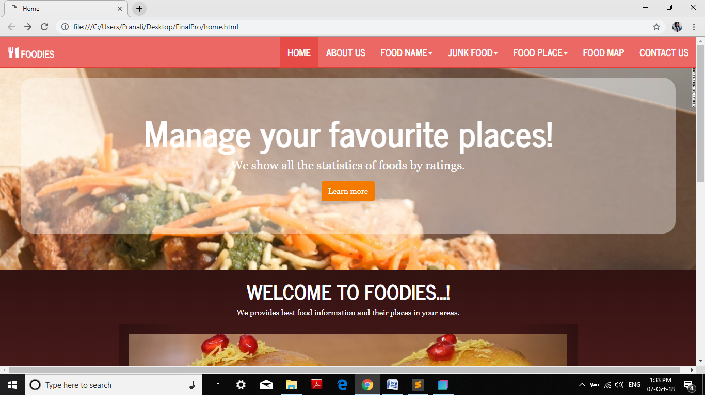

|  |  |  |  |  |  |  |
| --- | --- | --- | --- | --- | --- | --- |
| Test Case ID | Test  Scenario | Test Steps | Test Data | Expected  Output | Actual  Results | Pass/Fail |
| TC01 | When click the learn more button it must take the user to its redirected. | 1. 1. Go to site <file:///C:/Users/Pranali/Desktop/FinalPro/home.html> 2. Click on learn more button. | None | When click the learn more button then redirect the next web page. | As expected | Pass |
| TC02 | When click on the navigation items they must take user to corresponding link pages. | 1. Go to site <file:///C:/Users/Pranali/Desktop/FinalPro/home.html> 2. Click on any of navigation item. | None | When click on navigation item then go to the corresponding link page. | As expected | Pass |
| TC03 | When click on logo on the page it should go to the home page. | 1. Go to site <file:///C:/Users/Pranali/Desktop/FinalPro/home.html> 2. Click on logo of page. | None | When click on logo then go to their home page or redirected page. | As expected | Pass |
| TC04 | When mouse or cursor is scroll then it must scroll till footer page. | 1. Go to site <file:///C:/Users/Pranali/Desktop/FinalPro/home.htm> 2. Scroll the mouse on page. | None | Webpage should scroll down till footer page arrives. | As expected. | Pass |
| TC05 | When click on any link of footer page then it should be redirected properly. | 1. Go to site <file:///C:/Users/Pranali/Desktop/FinalPro/home.html> 2. Go to footer page. 3. Click on any link in footer. | None | The link is work it go to there redirected page. | As expected | Pass |

**TEST CASE 02**

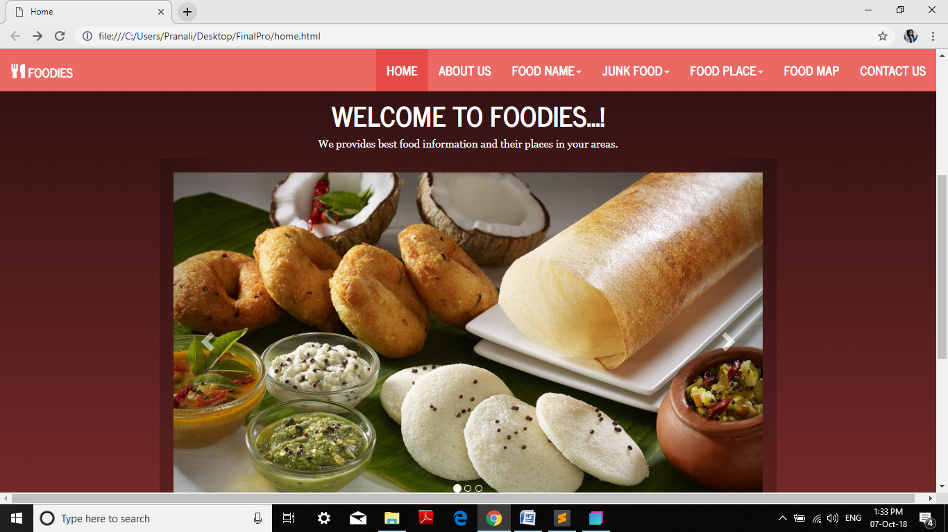

|  |  |  |  |  |  |  |
| --- | --- | --- | --- | --- | --- | --- |
| Test Case ID | Test  Scenario | Test Steps | Test Data | Expected  Output | Actual  Results | Pass/Fail |
| TC01 | Suitable design of the slider on all browsers (browser compatibility). | 1. Go to site <file:///C:/Users/Pranali/Desktop/FinalPro/home.html> 2. Go to the image slider. | None | Design of the slider is properly display on all browser. | As expected | Pass |
| TC02 | Smoothness and automatic loading of the slides. | 1. Go to site <file:///C:/Users/Pranali/Desktop/FinalPro/home.html> 2. Go to the image slider. | None | Image slider is automatically loaded. | As expected | Pass |
| TC03 | * Correct order of the slider images. | * 1. Go to site <file:///C:/Users/Pranali/Desktop/FinalPro/home.html>   2. Go to the image slider. | None | Image slider order is correct. | As expected | Pass |
| TC04 | * Whether the slides can be clicked and thumbnail is getting displayed on mouse overing. | * 1. Go to site <file:///C:/Users/Pranali/Desktop/FinalPro/home.html>   2. Go to the image slider.   3. Click the thumbnail. | None | Thumbnail is display on the slides. | As expected. | Pass |
| TC05 | When click the next thumbnail image should be change. | * 1. Go to site <file:///C:/Users/Pranali/Desktop/FinalPro/home.html>   2. Go to the image slider.   3. Click the thumbnail arrow. | None | Image is change when click the thumbnail arrow. | As expected | Pass |

**TEST CASE 03**

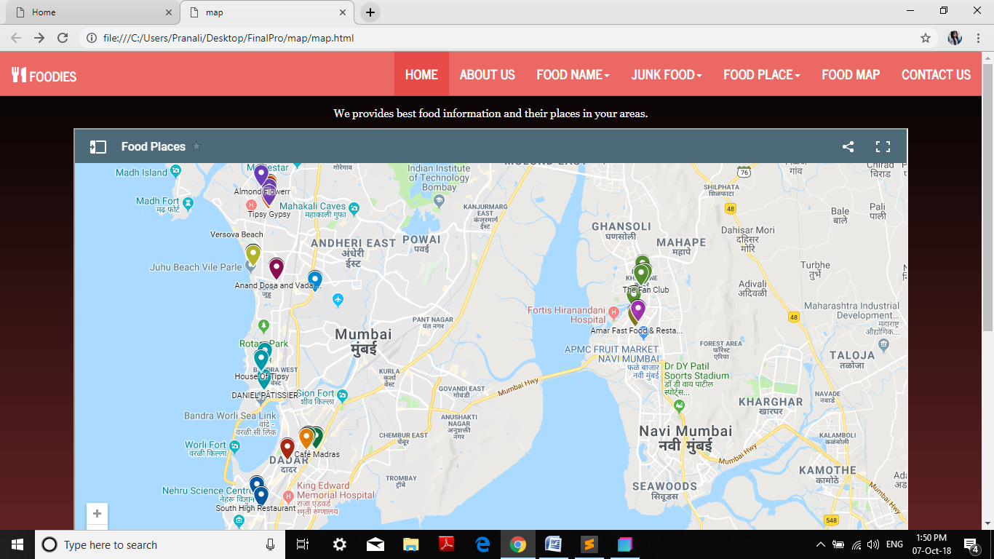

|  |  |  |  |  |  |  |
| --- | --- | --- | --- | --- | --- | --- |
| Test Case ID | Test  Scenario | Test Steps | Test Data | Expected  Output | Actual  Results | Pass/Fail |
| TC01 | When Click On Any Of The Maps Location/Places. The Map Must Show The Details Of That Place. | * 1. Go to site <file:///C:/Users/Pranali/Desktop/FinalPro/home.html>   2. Select the map option of navbar.   3. Click on any one of the place in map. | None | The map should show the location details. | As expected | Pass |
| TC02 | When click on zoom in button map must be zoom. | * 1. Go to site <file:///C:/Users/Pranali/Desktop/FinalPro/home.html>   2. Select the map option of navbar.   3. Click on zoom in button. | None | Map should zoom in and show places. | As expected | Pass |
| TC03 | When mouse hold and move side on map. The map must also move | * 1. Go to site <file:///C:/Users/Pranali/Desktop/FinalPro/home.html>   2. Select the map option of navbar.   3. Hold mouse click on map and move the map | None | The map should work on mouse hold. | As expected | Pass |
| TC04 | When click on zoom out button map must zoom. | * 1. Go to site <file:///C:/Users/Pranali/Desktop/FinalPro/home.html>   2. Select the map option of navbar.   3. Click on zoom out button. | None | Map should zoom out and show the places. | As expected. | Pass |
| TC05 | When pressing on map item in navbar it should work properly and goes redirected pages. | * 1. Go to site <file:///C:/Users/Pranali/Desktop/FinalPro/home.html>   2. Click on the map option of navbar. | None | Navbar should work properly and redirected the destinations page. | As expected | Pass |

**TEST CASE 04**

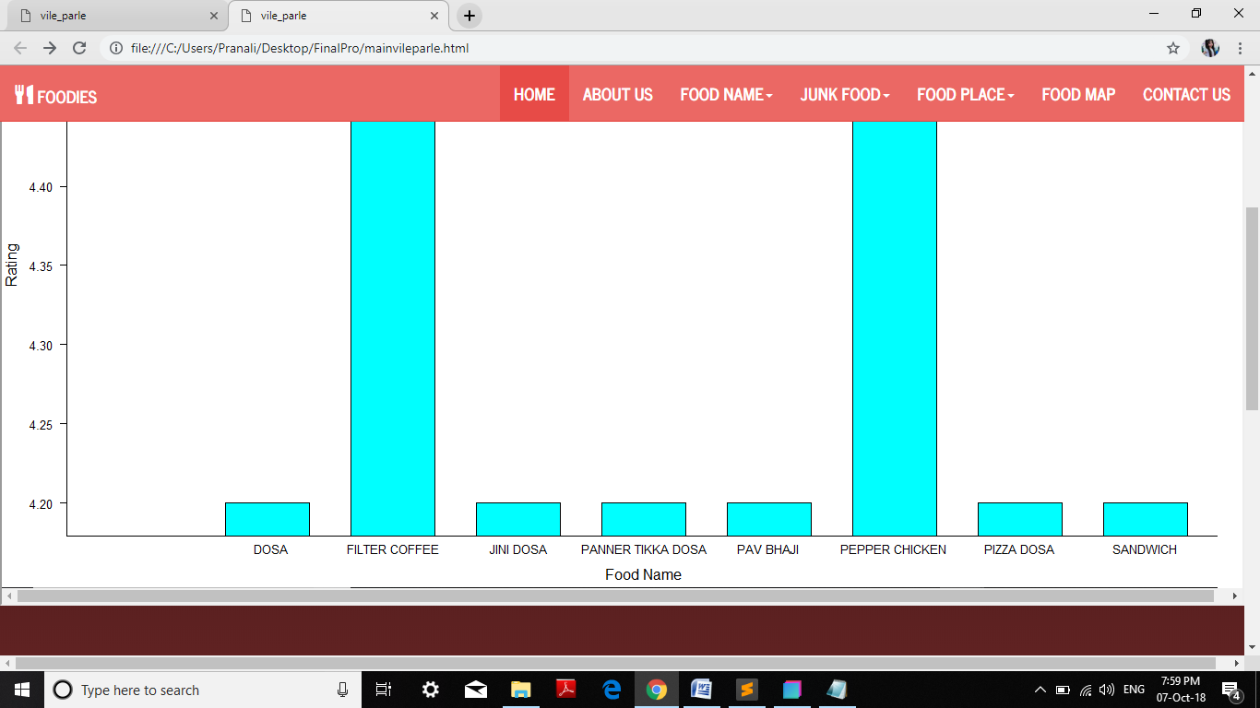

|  |  |  |  |  |  |  |
| --- | --- | --- | --- | --- | --- | --- |
| Test Case ID | Test  Scenario | Test Steps | Test Data | Expected  Output | Actual  Results | Pass/Fail |
| TC01 | When click the graph view then statistical graphs should be show. | * 1. Go to site <file:///C:/Users/Pranali/Desktop/FinalPro/home.html>   2. Click on the graph view of food place. | None | Click the graph view then graph is show. | As expected | Pass |
| TC02 | When mouse or cursor is scroll then it must scroll till footer page. | * 1. Go to site <file:///C:/Users/Pranali/Desktop/FinalPro/home.html>   2. Click on the graph view of food place. | None | Webpage should scroll down till footer page arrives. | As expected | Pass |
| TC03 | When click on the navigation items they must take user to corresponding link pages. | * 1. Go to site <file:///C:/Users/Pranali/Desktop/FinalPro/home.html>   2. Click on the graph view of food place. | None | When click on navigation item then go to the corresponding link page. | As expected | Pass |
| TC04 | When click the place view of graph then it should show the place wise. | * 1. Go to site <file:///C:/Users/Pranali/Desktop/FinalPro/home.html>   2. Click on the graph view of food place. | None | When click the place view graph then place wise graph is show. | As expected. | Pass |
| TC05 | Graph show in rating field of food items of one place. | * 1. Go to site <file:///C:/Users/Pranali/Desktop/FinalPro/home.html>   2. Click on the graph view of food place. | None | Graph show in rating wise. | As expected | Pass |

**TEST CASE 05**

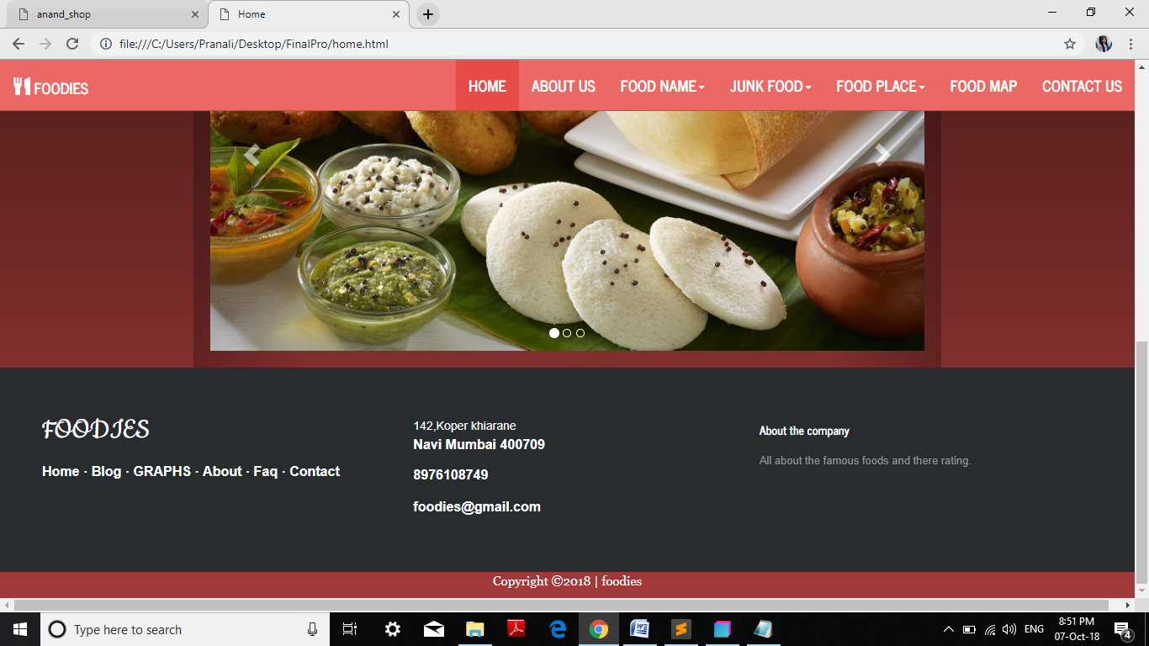

|  |  |  |  |  |  |  |
| --- | --- | --- | --- | --- | --- | --- |
| Test Case ID | Test  Scenario | Test Steps | Test Data | Expected  Output | Actual  Results | Pass/Fail |
| TC01 | When click on the navigation items they must take user to corresponding link pages. | 1. Go to site <file:///C:/Users/Pranali/Desktop/FinalPro/home.html>  2. Click on any of navigation item. | None | When click on navigation item then go to the corresponding link page. | As expected | Pass |
| TC02 | When click on logo on the page it should go to the home page. | 1. Go to site <file:///C:/Users/Pranali/Desktop/FinalPro/home.html> 2. Click on logo of page. | None | When click on logo then go to their home page or redirected page. | As expected | Pass |
| TC03 | When mouse or cursor is scroll then it must scroll till footer page. | 1. Go to site <file:///C:/Users/Pranali/Desktop/FinalPro/home.htm> 2. Scroll the mouse on page. | None | Webpage should scroll down till footer page arrives. | As expected | Pass |
| TC04 | When click on any link of footer page then it should be redirected properly. | 1. Go to site <file:///C:/Users/Pranali/Desktop/FinalPro/home.html> 2. Go to footer page. 3. Click on any link in footer. | None | The link is work it goes to their redirected page. | As expected. | Pass |
| TC05 | Check if default window size is correct. | 1. Go to site <file:///C:/Users/Pranali/Desktop/FinalPro/home.html> 2. Go to footer page. | None | Default window size is correct. | As expected | Pass |

1. **Graphs**

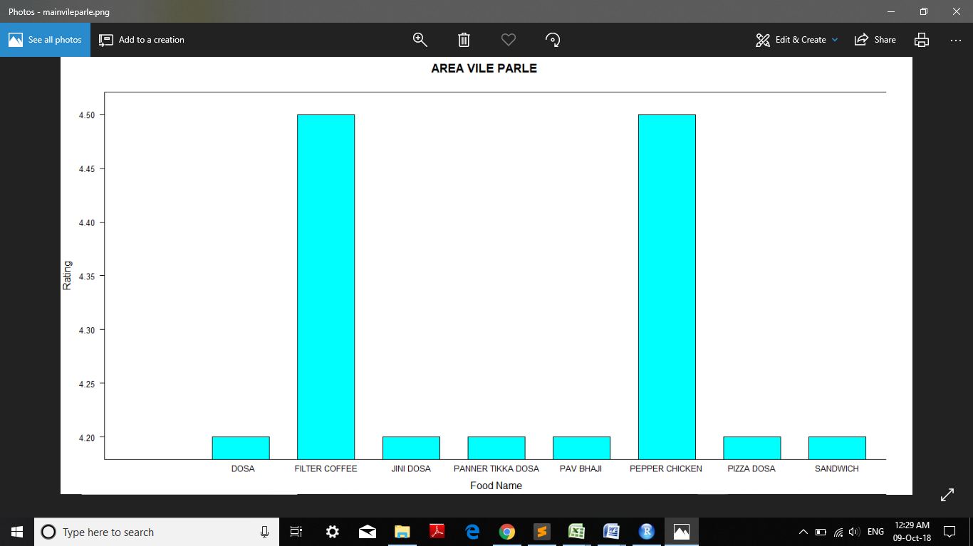

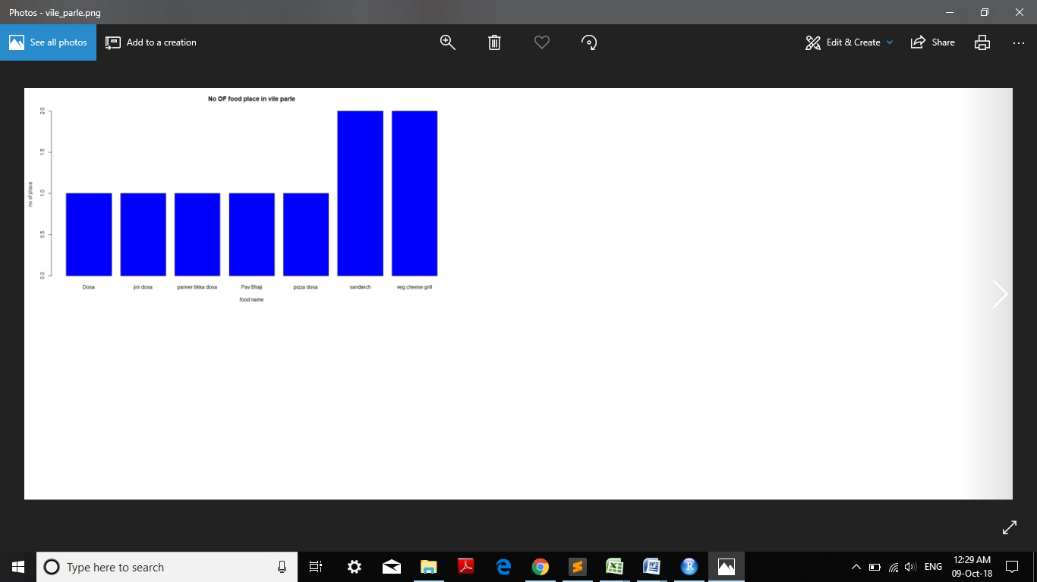

1. **Screen shots**

Home page





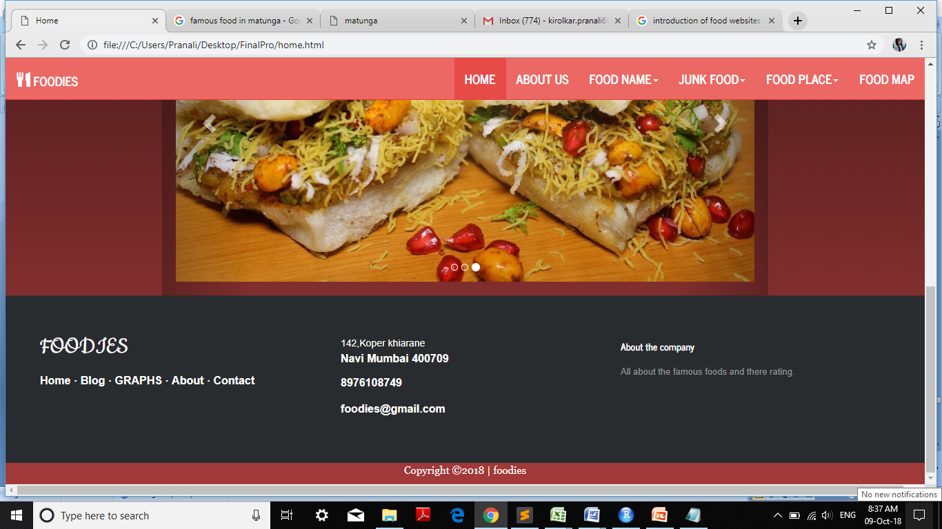

Dropdown menu of food place

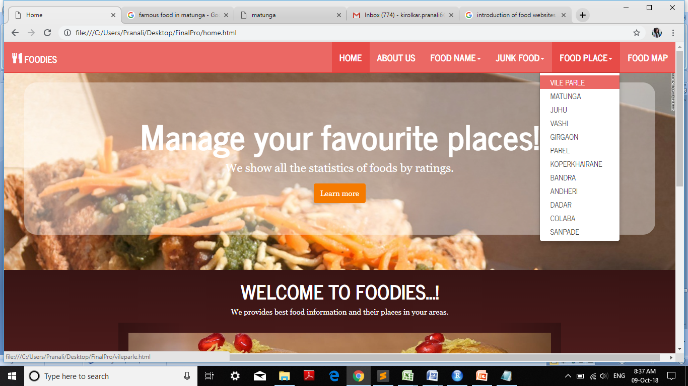

One of selected place information.

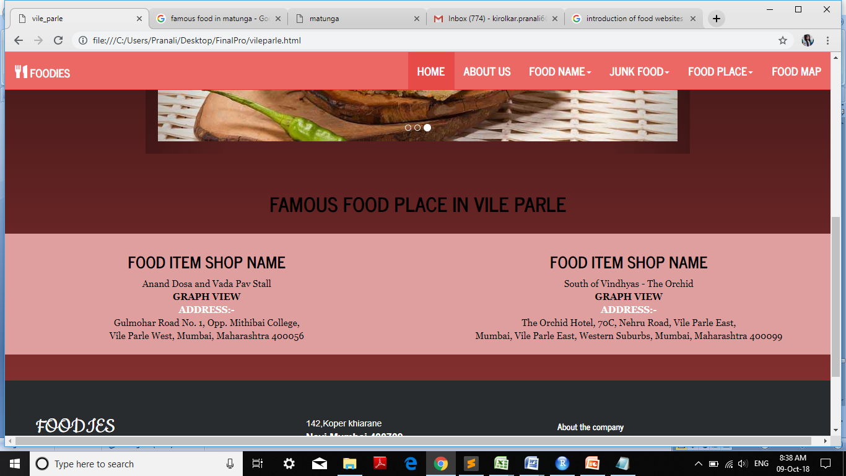

Graphical representation of main food place.

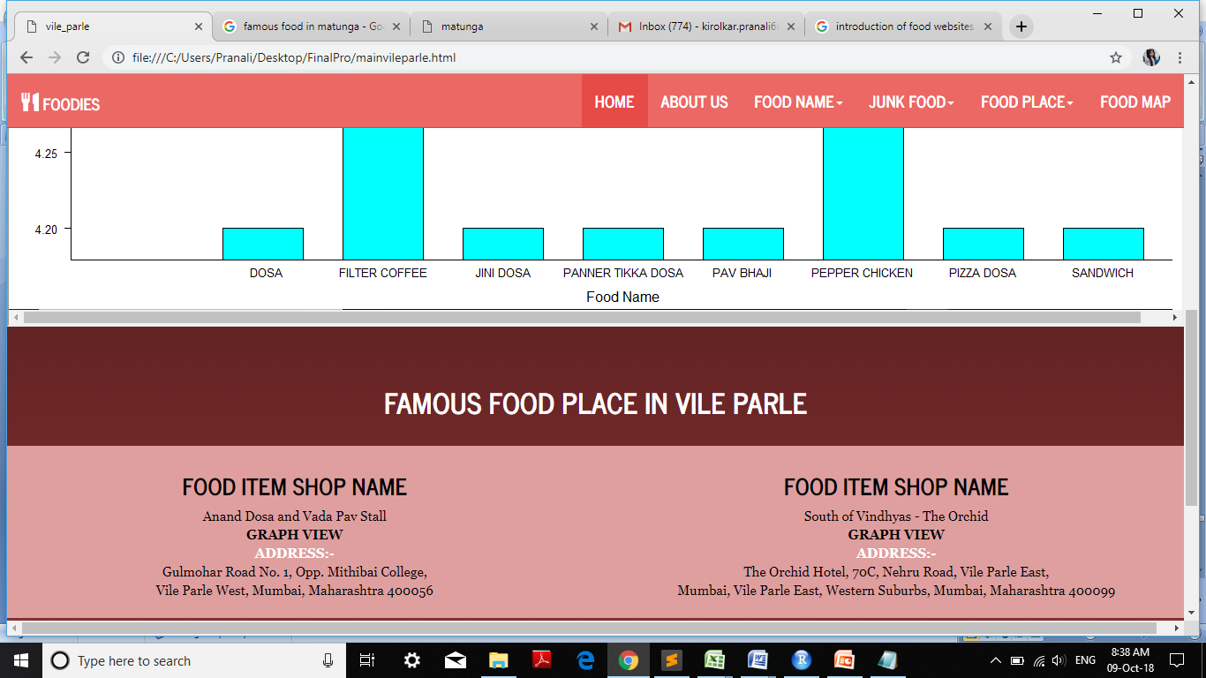

Famous food in selected area with their graphical representation.

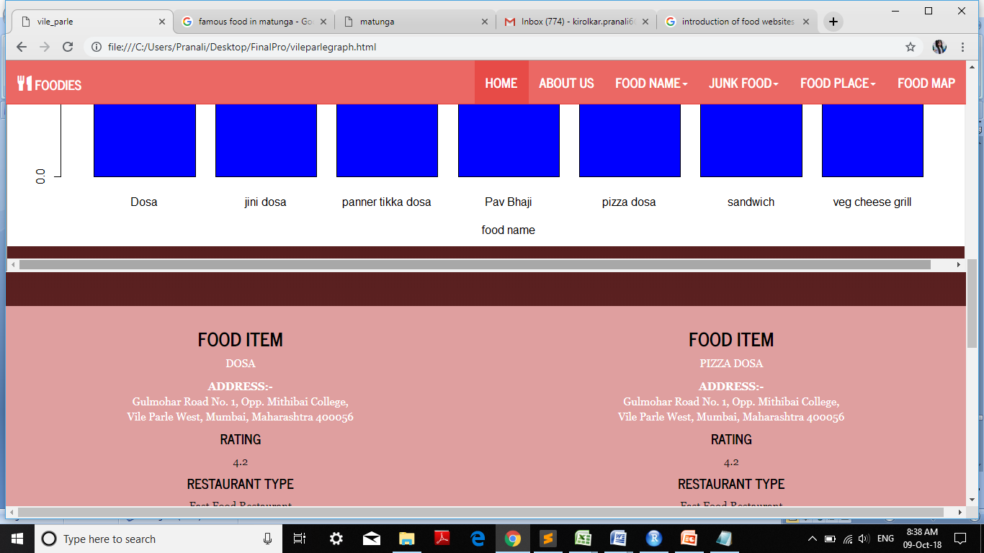

If you select the learn more button in home page then following page will be open.

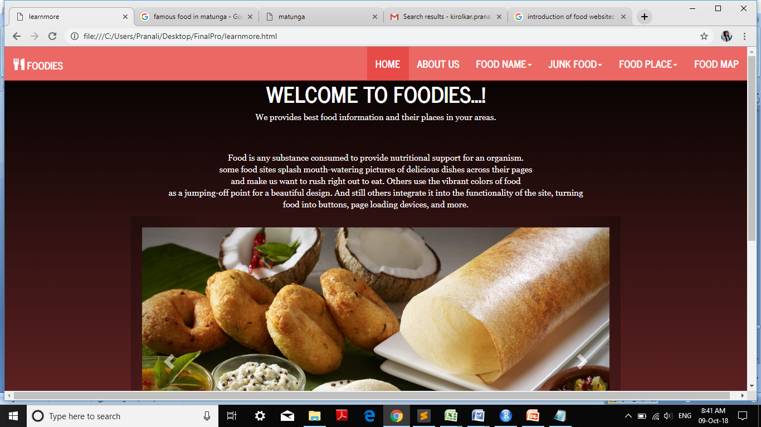

About us page

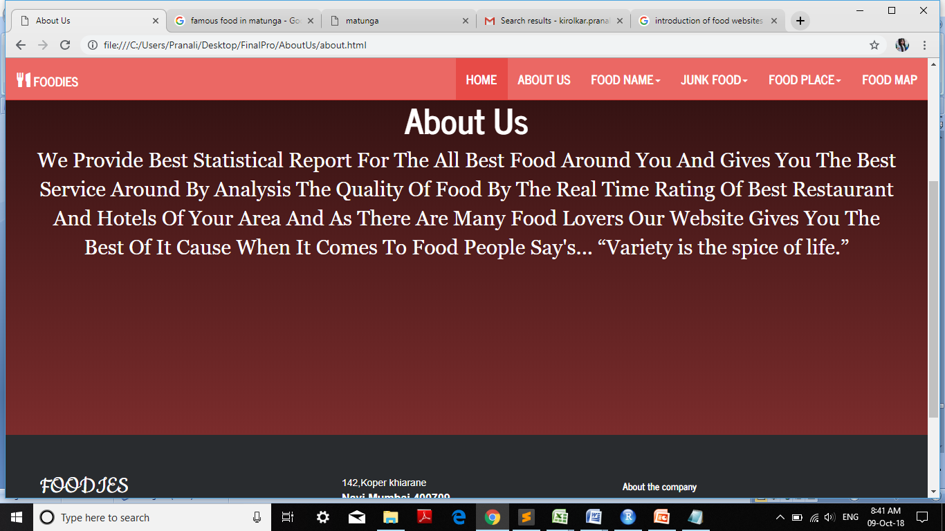

map view of food place with rating.

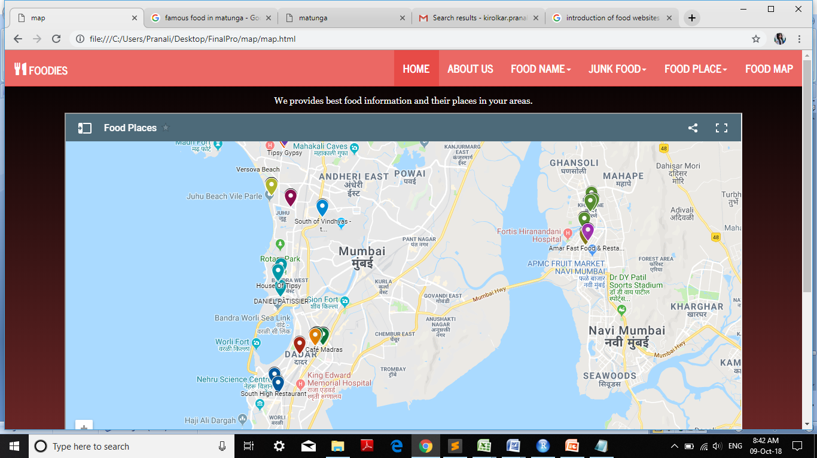

**Conclusion**

We are finding the famous food places and food items in Mumbai.

The people who loves the food gets the best of it, by using our website and get the statistical report for the food taste by the ratings of hotels and restaurant.

We also provide the best food by the area wise statistical report.

We also provide the map feature that will give you the best restaurant near your area by searching it.

**References**

* [**https://traveltriangle.com/blog/street-food-in-mumbai/**](https://traveltriangle.com/blog/street-food-in-mumbai/)
* [**https://www.theguardian.com/travel/2012/mar/01/10-best-street-food-mumbai-india**](https://www.theguardian.com/travel/2012/mar/01/10-best-street-food-mumbai-india)
* [**https://www.one.org/international/search/?ie=UTF-8&q=famous+food+in+india**](https://www.one.org/international/search/?ie=UTF-8&q=famous+food+in+india)
* [**https://www.indiacom.com/yellow-pages/restaurants/mumbai/**](https://www.indiacom.com/yellow-pages/restaurants/mumbai/)
* [**https://www.tripadvisor.in/Restaurant_Review-g304554-d12972440-Reviews-Papaya-Mumbai_Maharashtra.html**](https://www.tripadvisor.in/Restaurant_Review-g304554-d12972440-Reviews-Papaya-Mumbai_Maharashtra.html)